住院电子病历医嘱增加检验检查标签
一、当前省老年医院检验标签分类规则
、检验标签目录[select ZYZBID,ZYZBMC FROM BM_JYZYZB order by XSXH00,ZYZBID]
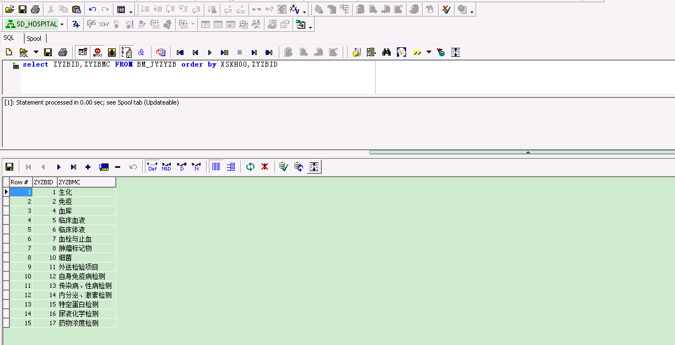
、检验标签目录明细
select distinct 'N' XZ0000,A.ZLXMID,A.ZLXMJC,A.SFJE00, D.CKZ000, ' ' JGSM00, D.JGDW00 ,a.YBLBMC, a.ZFBL00,a.NBLBMC,a.NBZFBL,0 zxks00,
' ' zxksmc,decode(A.LBBH00,'4',B.KSXMID,0) KSXMID,1 as SL0000 FROM VW_BQ_YBFYYZ a, XT_kszxxm b , VW_BM_ZLZD00 d where a.ZLXMID=D.ZLXMID and a.ZLXMID=b.ZLXMID(+) and A.ZYZBID='1' and ((a.YBZXLB='1' and a.YBBRLB='3'
and a.FBBH00='3') or (SFSFXM='N')) order by KSXMID,ZLXMID
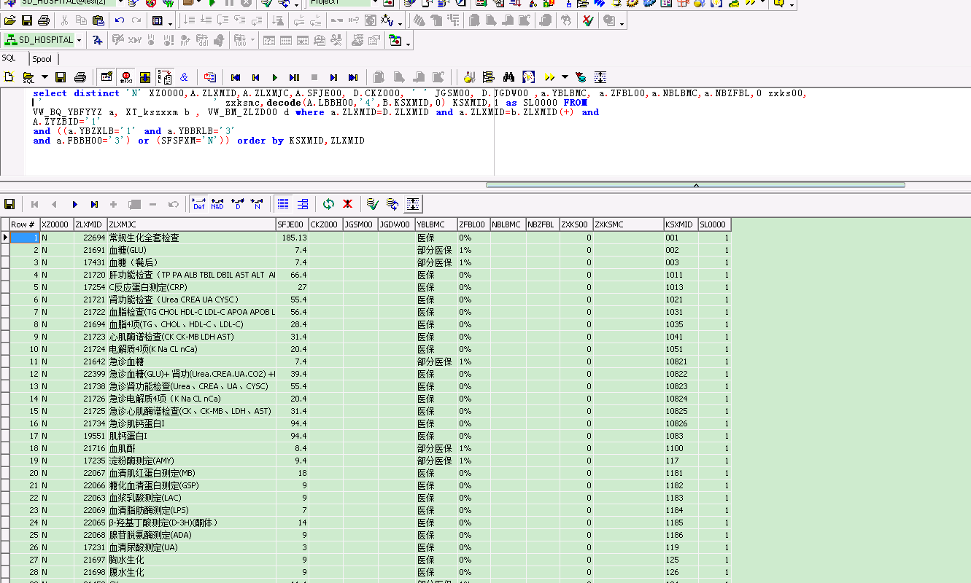
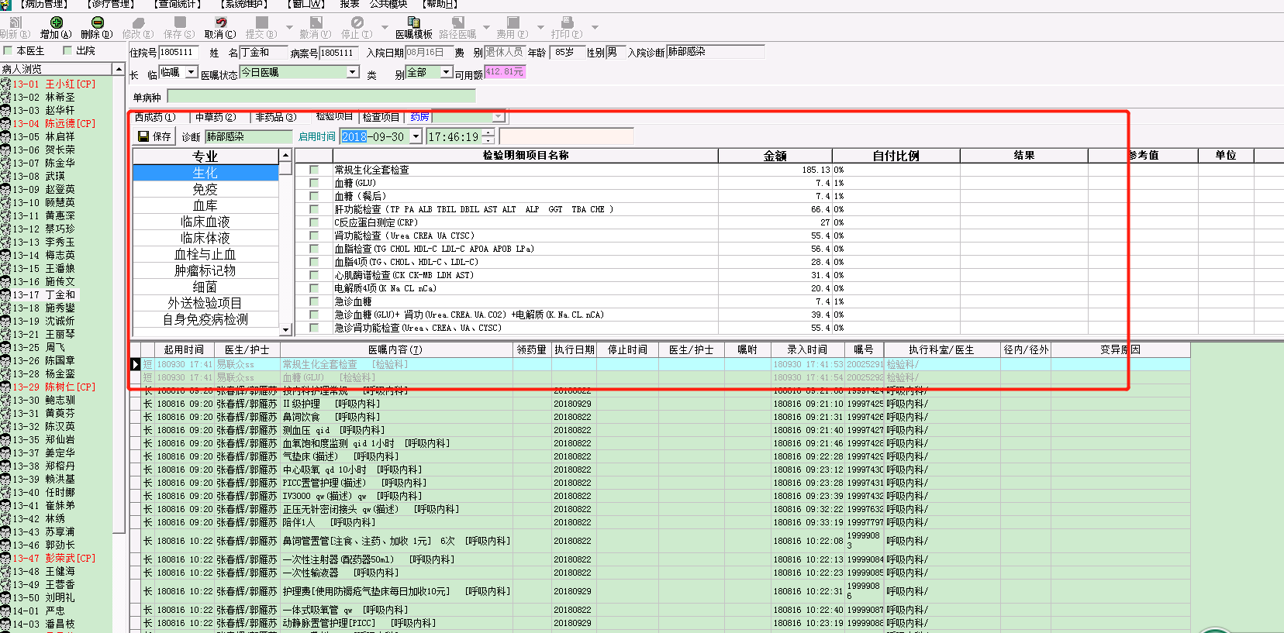

二、当前省老年医院检查标签分类规则
select a.*,JCMLID||','||SF_ZS_GETFLIDSTR(a.JCMLID) FLIDSTR,','||JCMLID||','||SF_YS_GETZJCMLID(JCMLID) ZJCMLID from BM_JCMLMX a order by CC0000,PXH000
