福建省人民医院电子病历系统故障情况汇报
2021年12月4日上午11点50分，省人民医院门诊电子病历系统和住院护士站出现操作缓慢，重新登录出现登录现象。后加剧HIS也出现缓慢，经故障分析和排查，运维人员将电子病历(含HIS)数据库重启，业务系统14:30恢复正常使用。
一、故障处理流程
发现问题时，现场实施人员从网络、负载均衡、应用以及数据库不同方面排查。在锁定问题来源后，将电子病历数据库重启操作，重启后业务恢复正常使用。

二、问题排查及分析
通过导出故障前(9:00-10:00)、故障发生时(11:00-12:00)、故障中(12:00-13:00)的AWR报告，初步分析故障主要原因:
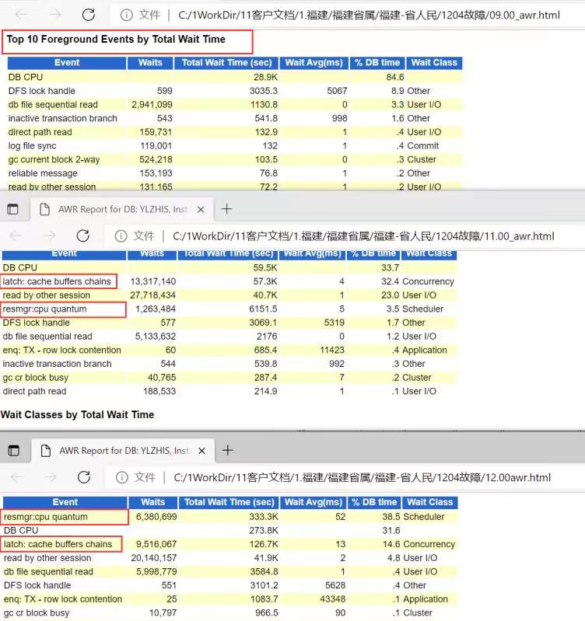
图1

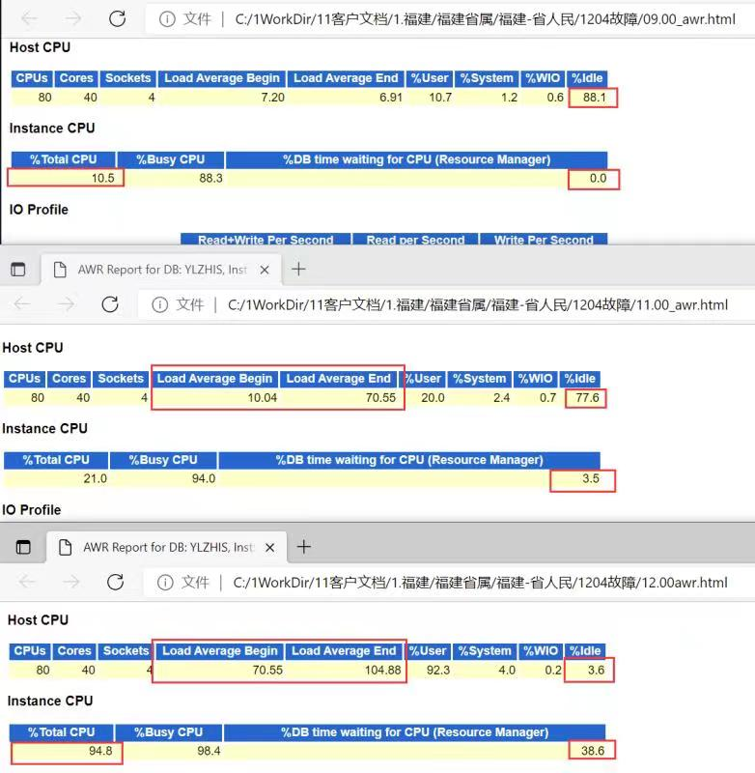
图2

分析如下：
在故障发生时可以看到file sequential read等待时间有明显上升，同时出现了resmgr:cpu quantum(资源调度进程)，因负载增加及个别语句不够优化，逻辑读太大造成闩锁（latch:cache buffers chains资源争用等待），触发了oracle启用资源调度进程，加剧了数据库性能恶化，最后造成oracle占用服务器CPU达到95%,服务器负担过高无法响应。后重启服务器，停止资源调度，问题得以解决。

三、情况汇报
经过调整，电子病历业务系统已恢复正常使用，后续将对此进行优化：
- SQL语句优化先进行优化；
- 系统参数全面检查；
- SQL优化后观察一段时间，再考虑是否关闭oracle资源管理功能；

四、需要优化的SQL语句

- select * from ( SELECT T.XSID00, T.BRXM00, T.ZYID00, T.RYCWH0, T.XSR000, T.XSRXM0, XSRQGG, T.XSRQ00, T.XSSJ00, T.xsxx00, T.BZ0000, T.HLJB00 FROM VW_BQ_RCXSJLCX T WHERE 1=1 AND T.BQH000 = :1 AND T.XSRQ00||T.XSSJ00 >= :2 AND T.XSRQ00||T.XSSJ00<= :3 union all SELECT null XSID00, (select XM0000 from ZY_BRXXB0 where ZYID00=t.ZYID00) BRXM00, t.ZYID00, t.ch0000 RYCWH0, null XSR000, null XSRXM0, null XSRQGG, null XSRQ00, null XSSJ00, '??' xsxx00, null BZ0000, null HLJB00 FROM bq_brldxx t where t.ch0000 in (select ch0000 from bm_cwk000 where bqh000=t.bqh000 and cwdj00 in (select cwdj00 from bm_cwdj00 where sfyx00 = '1' and cwdjmc like '%??%')) AND t.BQH000 = :4 AND t.qsrq00||t.qssj00 <= :5 AND nvl(t.jsrq00||t.jssj00, '2099123123:59:59')>= :6 ) where 1 = 1 ORDER BY RYCWH0, XSRQ00, XSSJ00

- SELECT a.*, b.JZYSXM, SF_BQ_CSRQTONL(b.CSRQ00) BRNL00, decode(a.FLAG00, '0', decode(nvl(a.ZDCLR0, ''), '', '???', '???'), '1', '???') JGZT00, b.JZRQ00, (select ZDMC00 from YS_BRZDXX c where a.ZYGHID = c.GHID00 and c.zzdbz0 = '3') ZDMC00, (select ZWXM00 from BM_YGBM00 f where f.YGBH00 = a.TZR000 ) TZRXM0, (select ZWXM00 from BM_YGBM00 f where f.YGBH00 = a.QRYS00 ) QRYSXM, (select ZWXM00 from BM_YGBM00 f where f.YGBH00 = a.ZDCLR0 ) ZDCLXM, (select ZWXM00 from BM_YGBM00 f where f.YGBH00 = a.SJCLR0 ) SJCLXM, (select BMMC00 from BM_BMBM00 f where f.BMBH00 = a.KDKSBH) KDKSMC FROM VW_YS_WJZTX0_MZDZBL a, SF_BRXXB0 b where 1=1 and a.ZYGHID = b.GHID00 and a.SFTXBQ = '1' and a.KDYS00 = :1 and a.FLAG00 = '0' and (a.MZSFCY <> 'Y' or a.MZSFCY is null) order by a.XXFSRQ||a.XXFSSJ

- SELECT a.*, c.SXYSXM, SF_BQ_CSRQTONL(c.CSRQ00) BRNL00, decode(nvl(a.ZDCLR0, ''), '', '???', '???') JGZT00, c.RYRQ00, c.RYZDMC , (select ZWXM00 from BM_YGBM00 where a.ANJSR0=YGBH00) ANJSRXM FROM VW_ZS_WJZTX0_ZYDZBL a, BM_BQKS00 b, ZY_BRXXB0 c where 1=1 and a.KDKSBH = b.KSH000 and a.ZYGHID = c.ZYID00 and a.SFTXBQ = '1' and b.BQH000 = :1 and a.ZDCLR0 is null order by a.XXFSRQ||a.XXFSSJ

- select a.brxm00 cname, a.zlxmjc testitemname, a.zy0000 REPORTVALUEALL, a.ywid00 SAMPLENO, a.yjdjh0, a.Zdclr0 from VW_ZS_WJZTX0_ZYDZBL a, zy_brxxb0 z where a.Zyghid=z.zyid00 and a.sftxbq='1' and SFZZJS='0' and z.brzt00 like '2%' and ((KDKSBH = 2477 and Zdclr0 = 4215) or (KDKSBH = 2477 and zdclr0 is null))

汇报人：林修远
汇报日期：2021-12-4

