该病人费用总额不等于支付总额
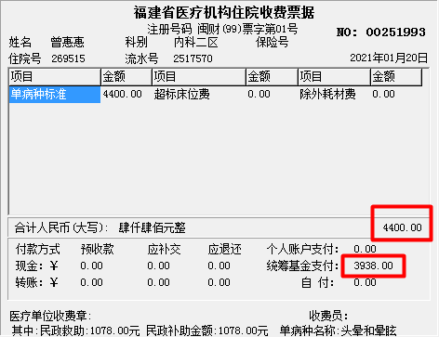
请求：
{
"data": {
"aac002": "350123196805185047",
"aac003": "曾惠惠",
"aaz149": "BZFZ00038",
"aaz500": "AB0157078",
"aka078": "20",
"aka130": "34",
"akc190": "10100144093",
"akc194": "20210120083059",
"akc227": "4685.32",
"amc020": "",
"amc026": "",
"amc028": "",
"amc029": "",
"bkc014": "20210120",
"bkc171": "083059",
"bke058": "9",
"bke078": "01",
"bke241": "50",
"bke284": "01",
"bke286": "2",
"bke298": "51401",
"bkec25": "",
"bkeg23": "1",
"bkz543": "",
"bmc041": "",
"cflist": [
{
"bke297": "26387867"
}
],
"ectoken": "",
"itemcount": "1"
},
"funid": "yb04.07.01.04",
"pwd": "3501236001123",
"usr": "3501236001"
}

返回：
{"traceid":"","flag":"1","data":{"bke174_mc":"市内","ake026":"0","akc087":"0","bkeg12":"0","fplist":[{"aka063":"01","bkc008":"1714.24","bkc009":"62.11","akc227":"1776.97","bkc010":"0","bkc011":"0.62","aka063_mc":"西药费"},{"aka063":"02","bkc008":"101.96","bkc009":"0","akc227":"101.96","bkc010":"0","bkc011":"0","aka063_mc":"成药费"},{"aka063":"05","bkc008":"0","bkc009":"320","akc227":"320","bkc010":"0","bkc011":"0","aka063_mc":"床位费"},{"aka063":"06","bkc008":"144","bkc009":"0","akc227":"144","bkc010":"0","bkc011":"0","aka063_mc":"诊察费"},{"aka063":"07","bkc008":"438","bkc009":"0","akc227":"438","bkc010":"0","bkc011":"0","aka063_mc":"护理费"},{"aka063":"08","bkc008":"232","bkc009":"34","akc227":"266","bkc010":"0","bkc011":"0","aka063_mc":"检查费"},{"aka063":"09","bkc008":"1271.5","bkc009":"22.5","akc227":"1294","bkc010":"0","bkc011":"0","aka063_mc":"化验费"},{"aka063":"10","bkc008":"241.5","bkc009":"0","akc227":"241.5","bkc010":"0","bkc011":"0","aka063_mc":"治疗费"},{"aka063":"13","bkc008":"67.85","bkc009":"0","akc227":"67.85","bkc010":"0","bkc011":"0","aka063_mc":"其他费"},{"aka063":"21","bkc008":"0","bkc009":"0","akc227":"35.04","bkc010":"0","bkc011":"35.04","aka063_mc":"其它医疗费"}],"ake007":"20210120","aaz149":"BZFZ00038","akc227":"3938","aaz500":"AB0157078","bkc014":"20210120","bkc059":"0","bka555":"01","bkc075":"0","aac006":"19680518","aac003":"曾惠惠","bkc011":"0","aac004":"2","bkc171":"82420","bkc052":"0","bke174":"3","bkc591":"0","aka151":"0","akb021":"福建省罗源县医院","aae011":"6001027","aka130":"34","mzlist":[{"bka542":"3D0100","bka542_mc":"民政医疗补助基金","bkeb34":"1078"},{"bka542":"390100","bka542_mc":"城镇居民基本医疗保险基金","bkeb34":"2860"}],"aka150":"2","bkc001_mc":"成年居民 ","bkc026_mc":"有效","ake173":"0","aac004_mc":"女","aka078":"20","aae072":"10170307343","bae029":"82420","bkc102":"3938","bkc026":"1","akc190":"10100144093","aab301":"350123","bkc001":"30","bkc045":"2860","bkc060":"1078","aac999":"65034975","bkc062":"0","bkc040":"0","bke361":"0","bkc041":"0"},"cause":""}

