确认发药查询

http://localhost:8181/ylzSoapServiceHttp/qrfycx/queryQrfy

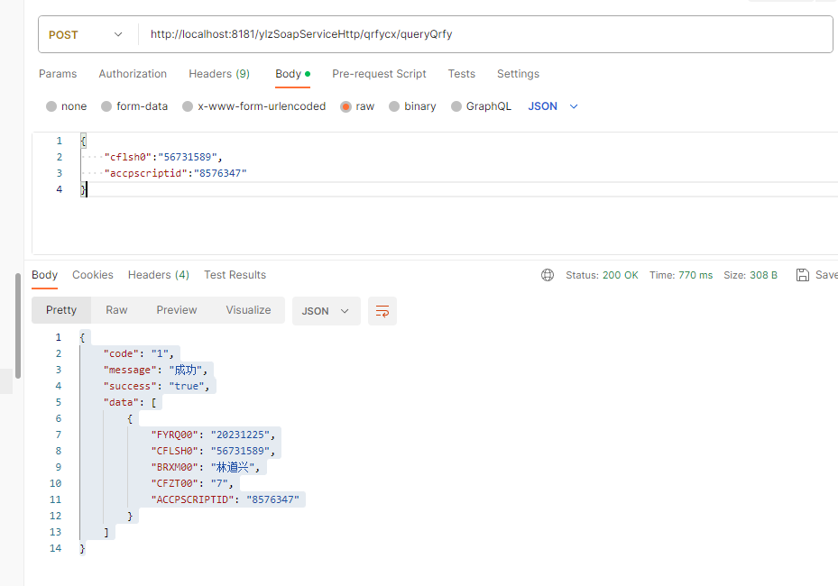

入参
cflsh0 | 处方流水号
accpsctiptid | 第三方主键

{
"cflsh0":"56731589",
"accpscriptid":"8576347"
}

出参
FYRQ00 | 发药日期
CFLSH0 | 处方流水号
BRXM00 | 姓名
CFZT00 | 状态
ACCPSCRIPTID | 第三方主键

失败
{
"code": "0",
"message": "失败未找到对应数据",
"success": "false"
}

成功
{
"code": "1",
"message": "成功",
"success": "true",
"data": [
{
"FYRQ00": "20231225",
"CFLSH0": "56731589",
"BRXM00": "林道兴",
"CFZT00": "7",
"ACCPSCRIPTID": "8576347"
}
]
}

