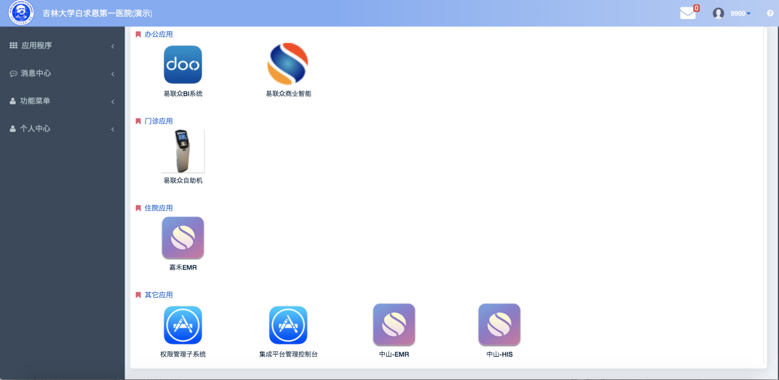
- 启动图标后的url地址为系统启动协议配置的地址加上sessionID数据.
如:http://xxx.xx.xxx.xxx:xxxx/xxx.xxx? sysName=权限管理子系统&sessionID=5AB948CF6A915D3FA0104465C01940FA
- 接入系统取的sessionID,调用登录webservice服务,获取用户菜单.
webservices地址为http://220.162.229.98:8087/com.ylz.gkpt/services/authoriytService?wsdl
方法：loginBySession
入参1: sessionid
入参2: sysName系统名称(即系统注册时产生的名称)
返回结果:
- sessionid无效,返回值为 {"success":false,"errorMsg":"无效sessionID."}
- sessionid正确,返回值为
其中userID为用户登录名
userMenu为用户菜单数据,userMenu下的childs为该用户的具体菜单数据.
userRole 为用户所拥有的角色.
userDept 为用户所拥有的部门.
mappingLognm 为用户在对应系统中用户名的映射登录名
sub_lognm指对应系统用户名
sub_pwd 对应系统密码（系统不可依赖此密码字段判断，特此说明）
（PS：可根据返回的sub_lognm用户名，success字段来判断是否为可登陆用户）

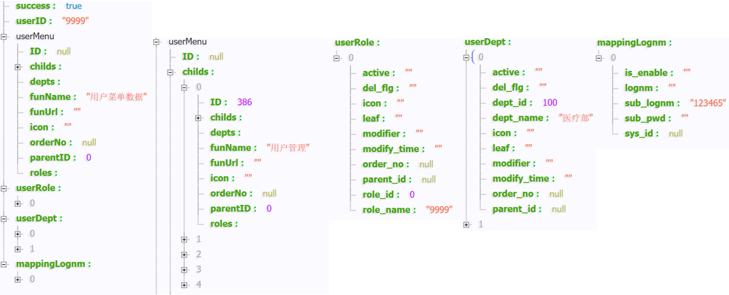
JSON串示例
{
"success": true,
"userID": "9999",
"userInfo": {
"birth_date": "1 ",
"email_address": "",
"id_card_number": "",
"in_service_state": "A",
"lognm": "9999",
"name": "管理员",
"phone": "15606958871",
"professional_title": "",
"sex": "",
"staff_attr_type": "",
"staff_id": "1"
},
"userMenu": {
"ID": null,
"childs": [],
"depts": [],
"funName": "用户菜单数据",
"funUrl": "",
"icon": "",
"orderNo": null,
"parentID": 0,
"roles": []
},
"userRole": [
{
"active": "",
"del_flg": "",
"icon": "",
"leaf": "",
"modifier": "",
"modify_time": "",
"order_no": null,
"parent_id": null,
"role_id": 0,
"role_name": "9999"
}
],
"userDept": [
{
"active": "",
"del_flg": "",
"dept_id": 100,
"dept_name": "医疗部",
"icon": "",
"leaf": "",
"modifier": "",
"modify_time": "",
"order_no": null,
"parent_id": null
},
{
"active": "",
"del_flg": "",
"dept_id": 101,
"dept_name": "管理部",
"icon": "",
"leaf": "",
"modifier": "",
"modify_time": "",
"order_no": null,
"parent_id": null
}
],
"mappingLognm": [
{
"is_enable": "",
"lognm": "",
"sub_lognm": "account",
"sub_pwd": "12345",
"sys_id": null
}
]
}
- 功能菜单新增接口
功能菜单新增可以调用insertFunInfo方法
参数sys_id: 系统ID
fun_name: 菜单名称
fun_url: 菜单url
parent_id: 父节点ID
userid: 当期用户在单点平台的ID
返回
success:true表示新增成功.
success:false 失败, errorMsg:具体错误信息.

