住院电子病历查看体温单，体温单项目显示不正常
住院电子病历体温单显示项目不对，通过日志查询是程序查询语句不对，程序语句直接查询全表数值，为进行分类，导致查询项目显示不对，导致数值填入不对，查看了住院护理文书系统对于的体温单列表展示语句，有明显区别，需要与护士文书系统对应，才能正常查看，详情请看下图：

住院电子病历显示及查询结果如下：
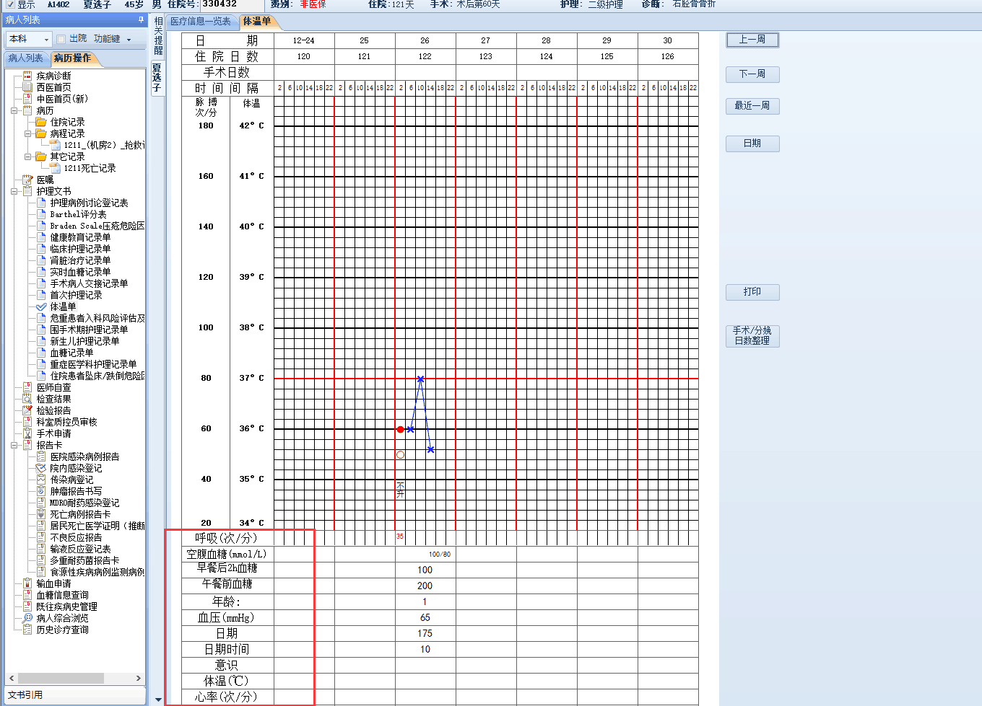

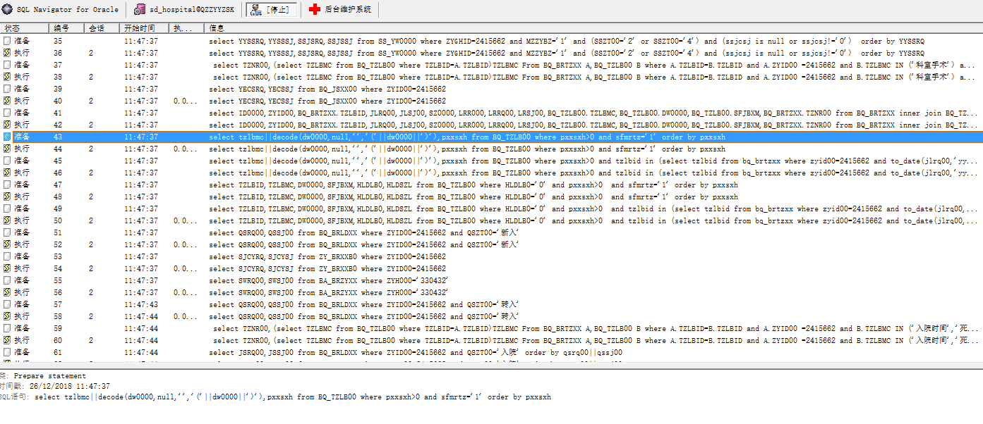
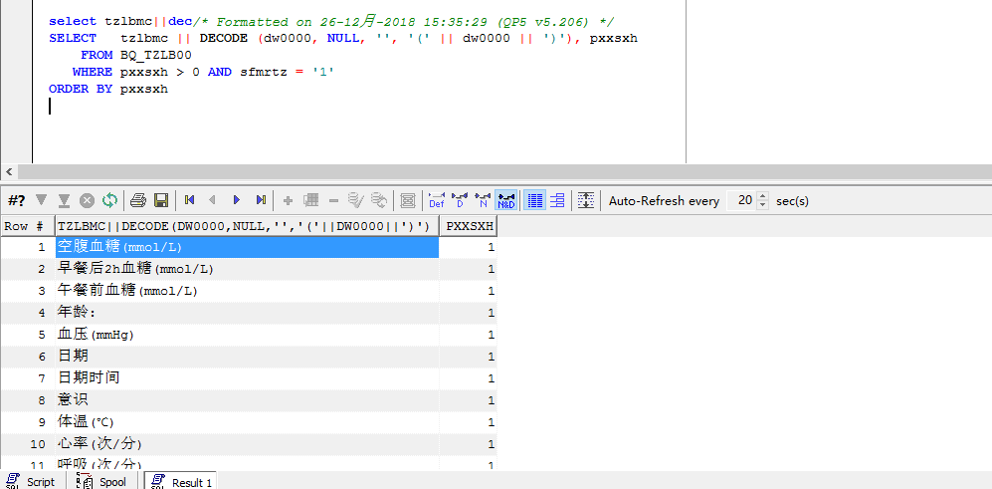

SELECT tzlbmc || DECODE (dw0000, NULL, '', '(' || dw0000 || ')'), pxxsxh
FROM BQ_TZLB00
WHERE pxxsxh > 0 AND sfmrtz = '1'
ORDER BY pxxsxh

住院护士文书系统显示如下：
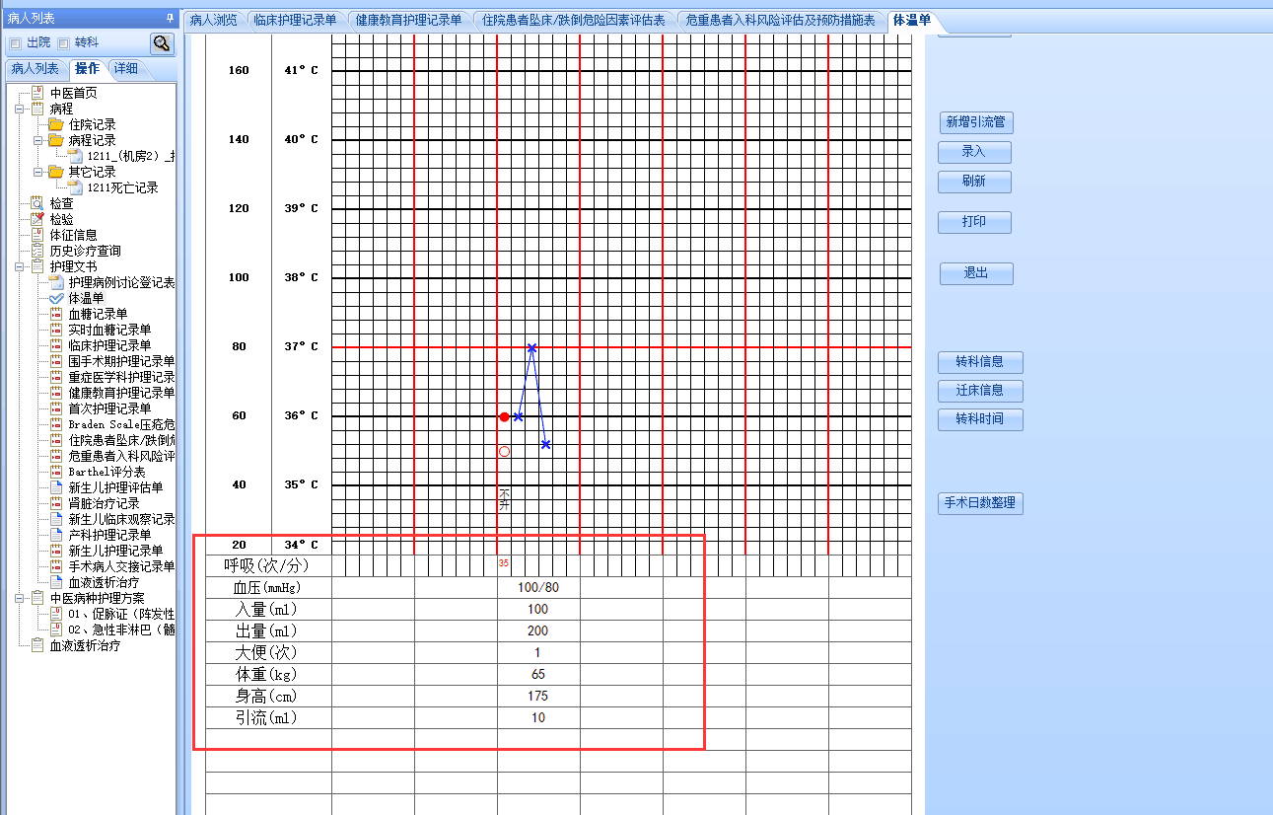

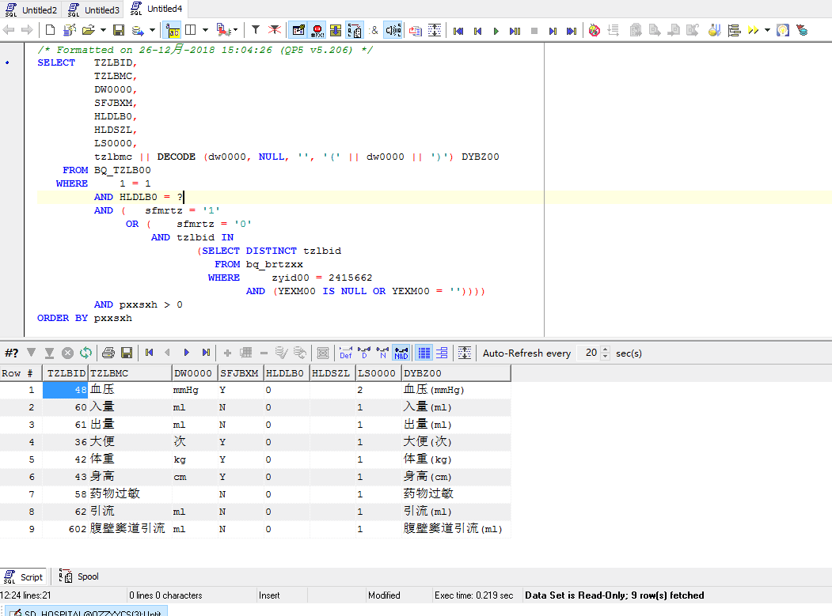

护士文书系统查询语句如下
SELECT TZLBID,
TZLBMC,
DW0000,
SFJBXM,
HLDLB0,
HLDSZL,
LS0000,
tzlbmc || DECODE (dw0000, NULL, '', '(' || dw0000 || ')') DYBZ00
FROM BQ_TZLB00
WHERE 1 = 1
AND HLDLB0 = ?
AND ( sfmrtz = '1'
OR ( sfmrtz = '0'
AND tzlbid IN
(SELECT DISTINCT tzlbid
FROM bq_brtzxx
WHERE zyid00 = 2415662
AND (YEXM00 IS NULL OR YEXM00 = ''))))
AND pxxsxh > 0
ORDER BY pxxsxh

变量：HLDLB0 = ?

