住院收费：单病种病人除外耗材打包（套、个）
字典参数：
BM_GZHCFL.HCDBSX is '耗材打包属性 0:按套打包 1:按个打包';
涉及过程:SP_ZY_YBJK00_FJ0000

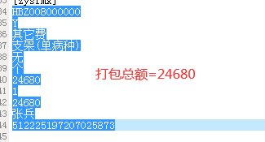

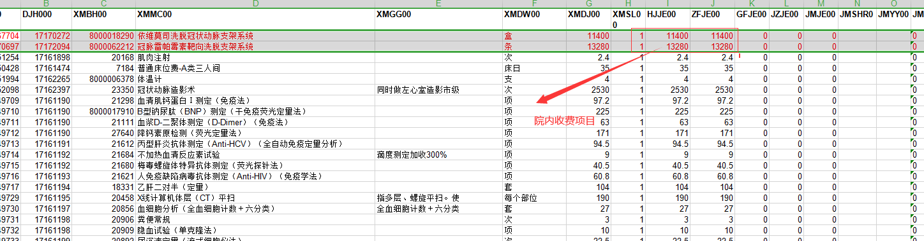

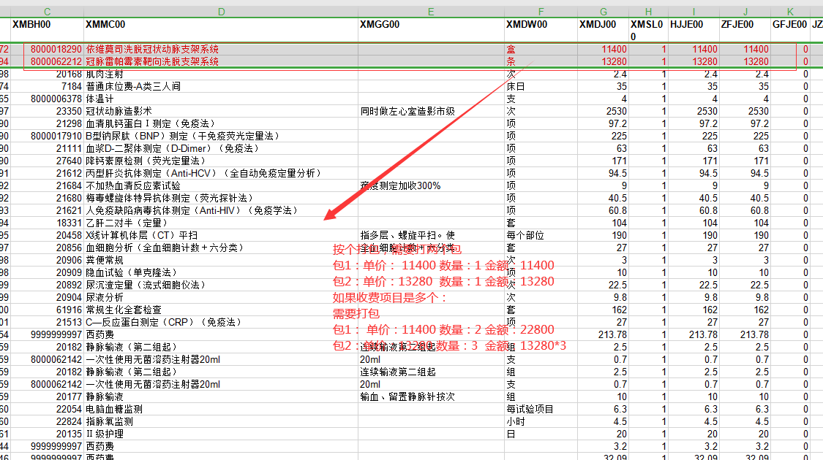

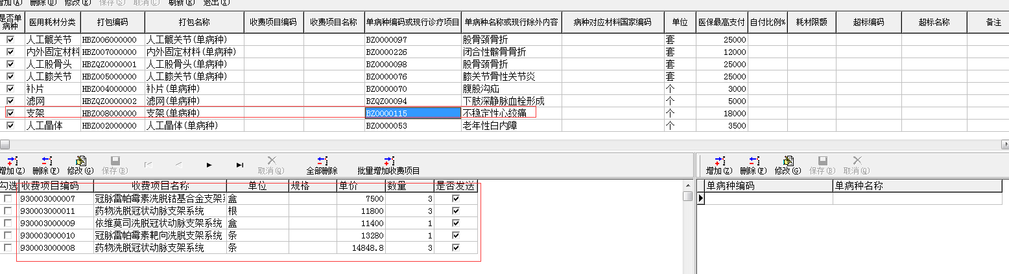

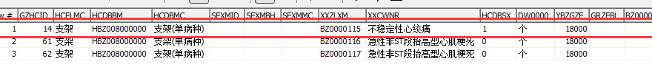

内部测试：
住院号：222940 zyid00=423239
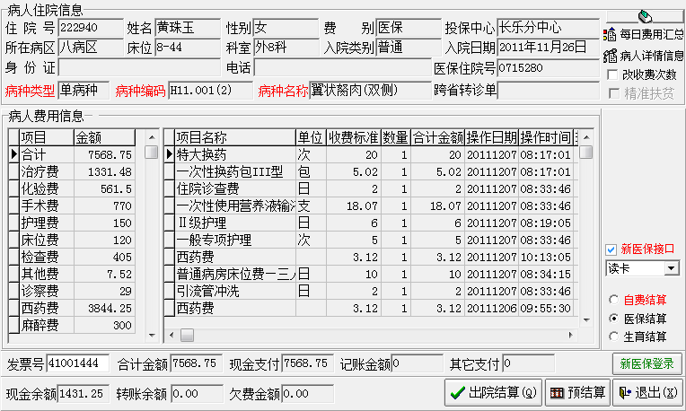

耗材打包收费项目查询语句：
select b.XMBH00,b.XMMC00,B.XMDJ00,sum(B.XMSL00)XMSL00,sum(B.HJJE00)XMJE00
from zy_brfy00 a,zy_fymx00 b where a.djh000=b.djh000
and a.zyid00=423239 and xmbh00 in (20150 ,20165,20186,23398,20076)
group by b.XMBH00,b.XMMC00,B.XMDJ00
order by xmbh00
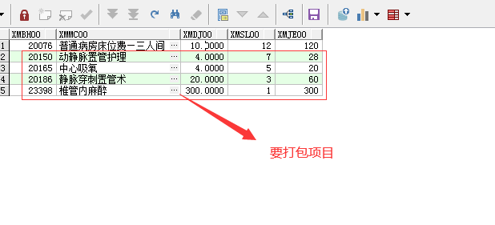
未启用按个打包：
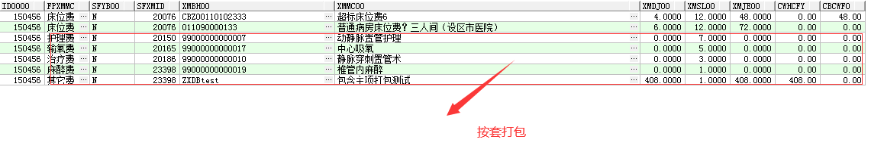
查询语句：
select ID0000,FPXMMC,SFYB00,SFXMID,XMBH00,XMMC00,xmdj00,xmsl00,xmje00, CWHCFY,CBCWF0
from zy_ybfsmx where zyid00=423239 and id0000=150456
and SFXMID in (20150 ,20165,20186,23398,20076 ) order by SFXMID;

字典设置某个项目按个打包：

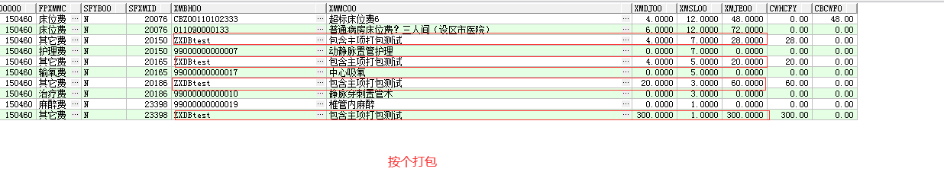
查询语句脚本：
select ID0000,FPXMMC,SFYB00,SFXMID,XMBH00,XMMC00,xmdj00,xmsl00,xmje00, CWHCFY,CBCWF0
from zy_ybfsmx where zyid00=423239 and id0000=150460
and SFXMID in (20150 ,20165,20186,23398,20076 ) order by SFXMID;

