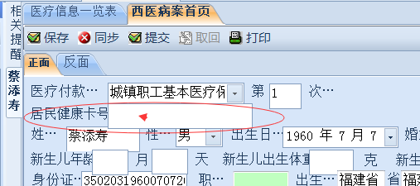
跟踪出来的语句中并不包含卡号字段，跟踪语句如下：
select A.BRID00,B.MRN000,A.YBLB00,BRXM00,BRXB00,BRXX00,RH0000,BRCSRQ,BRHYZK,BRZY00,BRMZ00,BRGJ00,BRZJLX,BRZJBH,A.FBBH00,FBMC00,BRJTDZ,BRYB00,BRDH00,BRLXGX,BRLXXM,BRLXDZ,BRLXDH,BRZTQK,BRJKQK,BRLX00,CZY000,CZRQ00,CZSJ00,ZYZT00,A.SFYX00,A.BZ0000,BRSZSF,BRSZS0,SWRQ00,SWSJ00,B.ZYID00,b.ZYH000, nvl(F.RYRQ00,b.RYRQ00) RYRQ00,nvl(F.RYSJ00,b.RYSJ00) RYSJ00,RYCZY0,CZYXM0,RYZD00,RYSQK0,RYBQ00,RZKS00,YSZID0,RYCWH0,DQBQ00,DQKS00,b.CYRQ00,b.CYSJ00,CYDJRQ,CYDJSJ,CYCZY0,CYYGXM,B.BRZT00 as BRZYZT,SZYS00,RYZDMC,BRRYCS,A.TYDWID,A.TYDWMC,A.TYDWYB,B.YBKH00,A.YBID00,ZWXM00,E.YBMC00,B.YBZYH0,B.ZZYS00,B.ZZYSXM,B.ZRYS00,B.ZRYSXM,B.SXYS00,B.SXYSXM, A.Brszsf,A.brszs0,A.brszc0,A.brszz0,A.brxzsf,A.brxzs0,A.brxzz0,A.brxzc0,A.BRBLH0,A.BRTZ00,sf_bq_csrqtonl(BRCSRQ) BRNL00,SJCYRQ,SJCYSJ from BM_BRXXB0 A inner join ZY_BRXXB0 B on A.BRID00=B.BRID00 left join BM_BRFBB0 C on A.FBBH00=C.FBBH00 left join Bm_Ygbm00 D on D.Ygbh00=B.SZYS00 and CZBZ00<>'2' AND (INSTR(YGXZ00,'0')>0 OR INSTR(YGXZ00,'1')>0) left join ZS_BLXX01 F on F.ZYID00=B.ZYID00 left join IC_YBBRLB E on E.FBBH00=B.FBBH00 and E.yblb00=B.yblb00 where B.ZYID00=20257

